Silicone Gaskets
Silicone gaskets developed by STUDYLITCS LABS PRIVATE LIMITED for the automobile industry are pivotal components that ensure optimal performance and reliability. Engineered with precision, these gaskets offer superior sealing capabilities, effectively preventing leaks and maintaining critical fluid containment within automotive systems. The inherent properties of silicone, such as resilience to extreme temperatures, chemicals, and mechanical stress, make these gaskets ideal for demanding automotive applications. Their durability ensures long-term functionality without degradation, reducing maintenance costs and enhancing vehicle lifespan. Additionally, silicone's flexibility allows for custom designs that conform perfectly to complex surfaces, ensuring a tight seal even in challenging environments. By prioritizing quality and innovation, STUDYLITCS LABS’ silicone gaskets contribute significantly to the efficiency and durability of automotive systems, affirming their essential role in modern vehicle engineering.

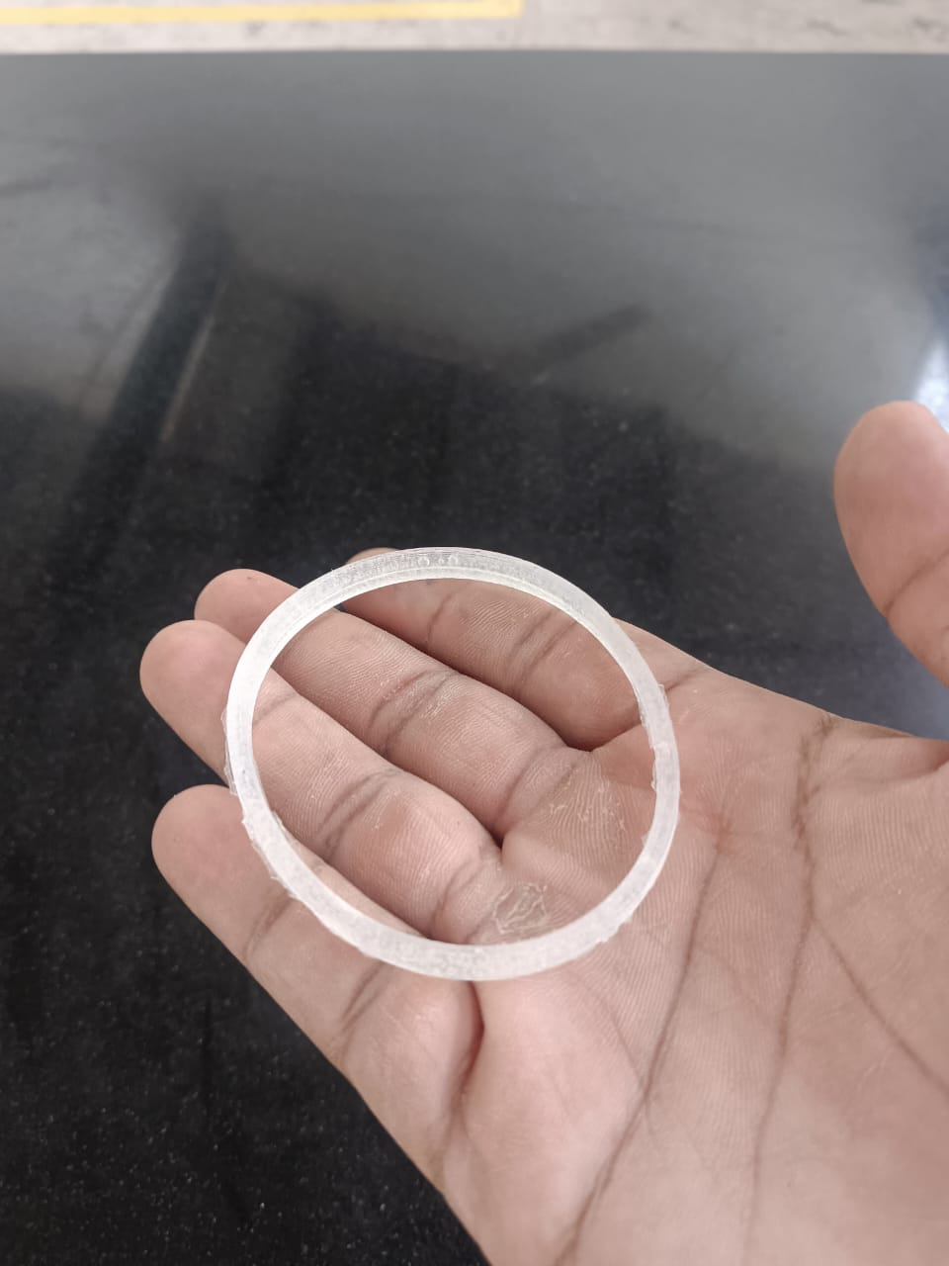

Silicone Gasket – 1
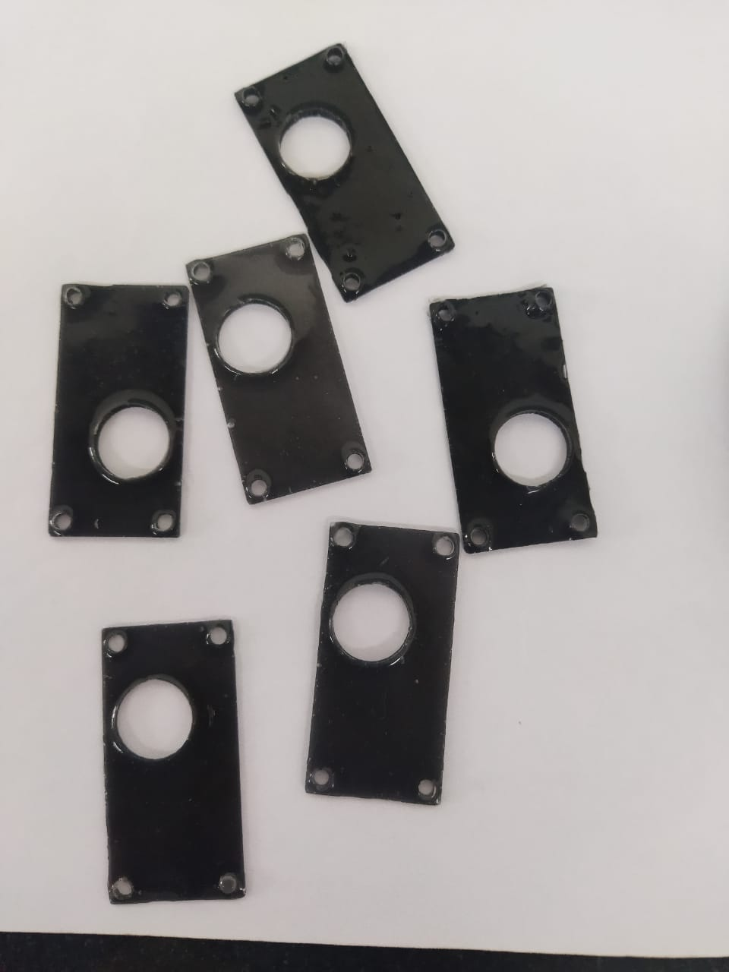
Silicone Gasket – 2
Silicone gaskets designed for automobile applications represent a pivotal advancement in automotive engineering, offering indispensable benefits across various components. Crafted from high-quality silicone rubber, these gaskets provide exceptional durability and resilience against extreme temperatures, chemicals, and environmental factors. Their superior sealing properties ensure leak-proof performance in critical engine, transmission, and exhaust systems, enhancing overall vehicle reliability and longevity. The flexibility of silicone rubber allows these gaskets to conform precisely to irregular surfaces, maintaining tight seals under dynamic conditions. Furthermore, their resistance to compression set and aging ensures consistent performance over extended periods, reducing maintenance costs and downtime. Whether used in engine compartments, electrical systems, or fluid handling components, silicone gaskets play a vital role in optimizing automotive efficiency, safety, and environmental sustainability, making them an essential choice for modern automotive applications.

